The Place Independent School
Transition Plan
Introduction:
All human beings have an optimal arousal zone, known as the Window of tolerance (Siegel, 2012) (see Figure 1) where they have capacity to manage emotions even when under stress. Where young people have experienced early life trauma, developmental, attachment or complex trauma, their autonomous nervous system becomes attuned to high levels of stress hormones (Cortisol and Adrenaline) and their capacity to self-regulate diminishes. This results in a narrow window of tolerance and over-reactions to present stressors with hyper-arousal (anxiety, hypervigilance, anger (Fight / Flight) or hypo-arousal (withdrawal, dissociation (freeze / fawn/ flop) responses.
Figure 1: Window of Tolerance (nicamb, 2019)
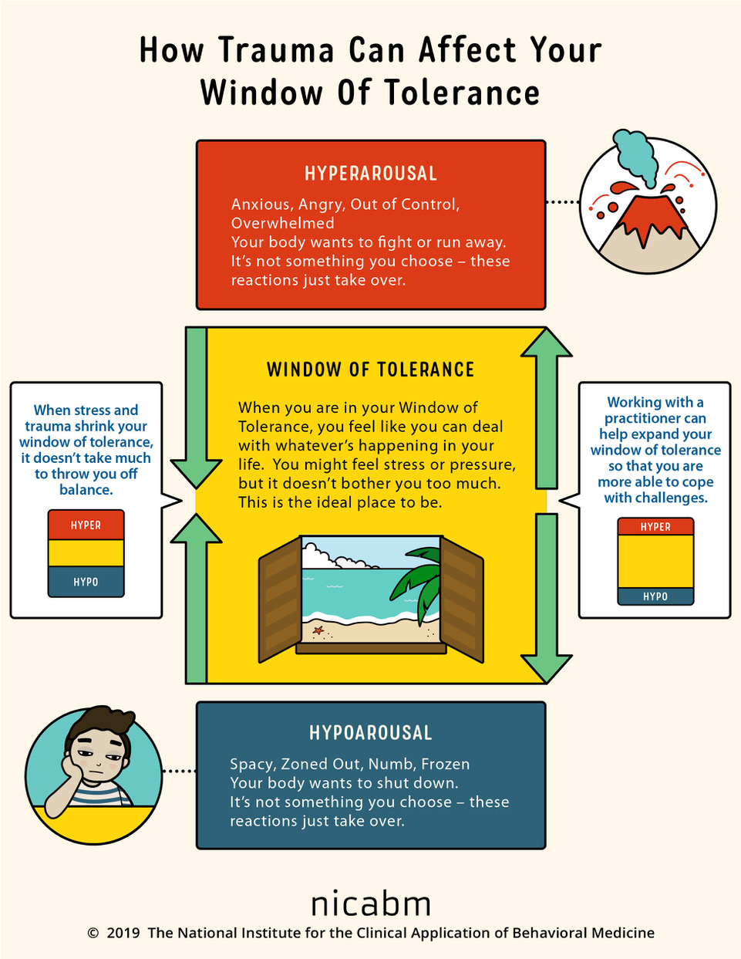
The Transition Plan implemented by The PLACE Independent School is designed to support young people to gradually expand their window of tolerance, gain a sense of safety from nurture, routine and safe boundaries and accept the school as a secure base from which to make and sustain meaningful attachment relationships. When a young person feels safe within their environment, their cognitive and social ability improves thus fostering a safe and successful transition to full time education which can be maintained in the long term.

Visit 1:
Visiting a new school for the first time will likely raise a young person’s anxieties outside of their window of tolerance, particularly if previous educational experiences have not been positive. Therefore, it is important that an adult accompanying the young person is someone that the young person has developed a trusting relationship with to allow for co-regulation.
Heightened anxiety and triggering of past trauma can also affect cognitive ability; hypervigilance on the first visit may result in the young person only focusing on their “safety” within the moment, therefore only a small number of staff are met on the first visit and a picture booklet is provided for the young person to take home with them. Caregivers can then facilitate the young person to view the booklet and process their first visit to the school, familiarise themselves with the school from a place of psychological safety and think about what else they would like to know about their new school, hence providing some autonomy to the young person.
The young person will also receive a transitional teddy bear. This is important for the first stages of emotional attachment to school and a sense of school becoming a safe space to develop. As with an infant’s blanket or soother, a soft toy provides a sense of comfort and security which the child can carry with them. Moreover, the transitional teddy bear gives the young person the opportunity to explore how they are feeling about attending a new school whilst remaining safe within the 3rd person. For example, curiosity from care givers around how “Teddy” might be feeling about coming to a new place away from his carers, and what might make “Teddy” feel safe can give the young person opportunity to relate to how they are feeling and to give voice to their feelings via the “teddy”.

Visit 2:
The young person re-visits the school with their trusted adult. Having been able to view the school booklet with care givers, the young person is less hypervigilant and more able to make sense of their surroundings. The visit is led by the Young Person’s questions such that the young person is given some agency in their own sense of safety but also feels acceptance.
A member of the senior leadership team will ask the young person if they would like to come to this school. This invitation lets the young person know that they are accepted and indeed wanted but also enables them to retain autonomy in “choosing” their school. The young person is welcomed into the school, receives their uniform and thus begin to gain a sense of belonging to the school community.

Start of School:
The table below outlines the transition plan to full-time education for young people attending The Place Independent School. It is designed to gradually expand the young person’s window of tolerance through titrating exposure to the routine and boundaries of the school day and to daily social interactions thus providing a successful transition to full-time education which can then be maintained.
Week 1 | Monday – Friday 9-12.00 noon
Week 2 | Monday – Friday 9- 12.30 (lunchtimes introduced)
Week 3 | Monday 9-3pm, Tuesday – Friday 9-12.30 (Lunch at school)
Week 4 | Monday & Tuesday 9-3pm, Wednesday -Friday 9-12.30 (lunch at school)
Weeks 5-7 | Full days continue to be added until attending full-time **

Table 1. The PLACE Independent School Transition Plan
Week One is designed to assist the young person into a new routine of getting up and attending school each day; routine and the introduction of boundaries help to reduce anxiety and instil a sense of safety through predictability – school becoming a consistent, reliable, safe care-giver, meeting an early relational need of many young people who have experienced developmental trauma. Social interactions are introduced gradually via morning club. Morning club also gives the young person time to transition to school surroundings and reduce anxiety before more cognitive academic tasks are undertaken. Young people and school learn and adapt to the expectations each has of the other.
During Week 2 young people stay for lunch at school. Mealtimes can be a source of much anxiety for many young people since both the uncertainty of having hunger relieved and uncertainty surrounding social group expectations can be triggering. By gradually introducing a lunchtime routine, young people gain further reassurance from the predictability of nurture and can be supported to practice social interactions in a safe environment.
From Week 3 through Week 7, afternoon learning sessions are gradually added week by week. A phased change of routine enables the young person to gradually adapt to full time education and become accustomed to changes of staff; this titrated method of introducing full time education being designed reduce the likelihood and impact of emotional, cognitive and physical exhaustion.
** Every young person is an individual and their capacity to accept co-regulation and / or self-regulate and adapt to change will vary according to familial, environmental and social factors. Young people are closely monitored for any signs of psychological distress and re-traumatisation throughout the transition period and should any young person present as not managing the expectations of an increased school timetable then the process between weeks 5 and 7 will be slowed accordingly, whilst still maintaining the aim for young people to successfully attend and maintain full time education within an acceptable time frame.
Siegel, D.J. (2012). The Developing Mind: How relationships & the brain interact to shape who we are. New York, USA: Guildford Press.

